**INS TUBE FLAP CHECKING TOOL GUIDE**

1. **Open SAP and Navigate to Transaction:**
   * Go to Transaction **ZNBPSTK**.
   * Enter your plant code and Execute.
2. **Select Layout:**
   * From the layout options, select the **2nd layout** from the top. Make sure data is in the below sequence: - Material > Material Description > Plant > Storage Location > Value > Unrestricted.
3. **Export to Spreadsheet:**
   * Export only by Right-clicking anywhere in the data and choose **Export > Spreadsheet**.

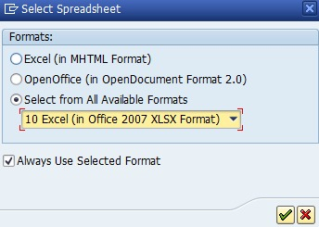

* + Save the file in your desired location when prompted, and it will open automatically.

1. **Create a New Sheet for Undelivered Stock:**
   * In the opened spreadsheet, create a new sheet named **"UD"** after **Sheet1**.
   * In the **"UD"** sheet, starting from cell **A1**, paste the data for undelivered stock obtained from transaction ZDL. You may sort the Product code and copy below required fields directly from data of ZDL to sheet **“UD”** in cell **A1**. Only below 3 columns needed in sheet UD in following respective sequence.
     + **Column A**: Product code
     + **Column B**: Product description
     + **Column C**: Quantity
2. **Return to Sheet1:**
   * After entering the undelivered stock data, go back to **Sheet1**.
3. **Use the M R F Tab in Excel:**
   * In the **"M R F"** tab next to the **Home** tab in Excel, click on the **"Stock Taking"** icon.
4. **Execute the Stock Taking Process:**
   * The tool will execute the stock-taking programme. Wait for it to complete.
5. **Finish:**
   * Once the process is complete, review the results as needed in auto created worksheet **TTF2**.